Beomjin Han
CSC 138-03
Dr. Xuyu Wang
Ex 2
- 01100110 10011111
+ 10101010 11010001
00010001 01110001
Checksum is 11101110 10001110
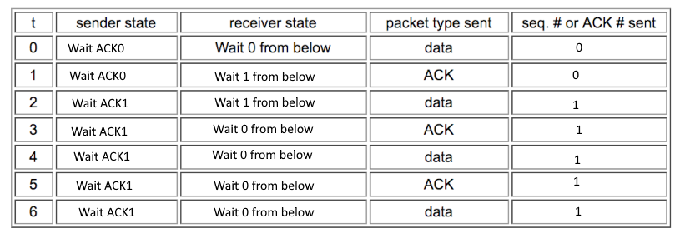
- At times 1 and 3 the payload was passed up to the higher layer at the receiver.

Sender to Receiver | Time segment sent | Sequence number | Time segment received | ACK value
Segment 1 | 1 | 149 | 8 | 705
Segment 2 | 2 | 705 |  | No ACK
Segment 3 | 3 | 1261 | 10 | 705
Segment 4 | 4 | 1817 |  | No ACK

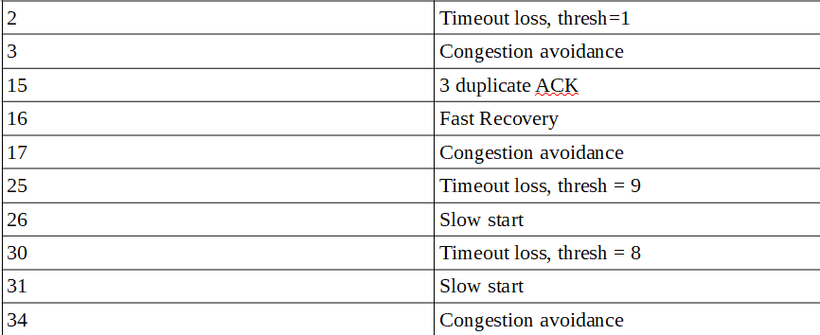
- RTT’s: 270, 230, 290, 210
first deviation: 29
a = 0.125
b = 0.25
after first estimate:
estimatedRTT = 0.875*270 + 0.125*230 = 265 msecs
DevRTT = 0.75*29 + 0.25(abs(230 - 265)) = 30.5 msecs
TimeoutInterval = 265 + 4*30.5 = 387 msecs
after second estimate:
estimatedRTT = 0.875*265 + 0.125*290 = 268.125 msecs
DevRTT = 0.75*30.5 + 0.25(abs(290 – 268.125)) = 28.34375 msecs
TimeoutInterval = 268.125 + 4*28.34375 = 381.5 msecs
after third estimate:
estimatedRTT = 0.875* 268.125 + 0.125*210 = 260.859375 msecs
DevRTT = 0.75* 28.34375 + 0.25(abs(210 - 260.859375)) = 33.97265625 msecs
TimeoutInterval = 260.859375 + 4*33.97265625 = 396.75 msecs

